To Record Your Tour:

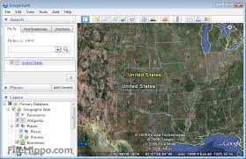

- Click the record tour button.
- Click the red record button and the mic button (make sure that they both turn bold)
- Begin speaking and recording your tour
- When you are finished recording, click the “X”
- Click the “save” icon
- Name your file “your tour with sound” (for example: Germany Tour with Sound”
- Right click on the finished tour and choose ‘save place as’ and then save it to your network folder

